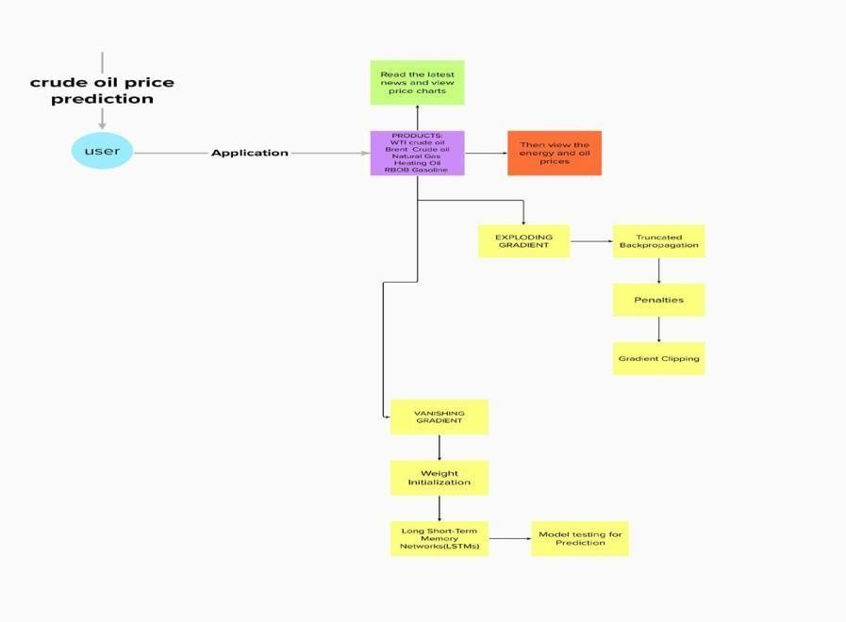

Project Design Phase-II

Data Flow Diagram & User Stories

|  |  |
| --- | --- |
| Date | 03 October 2022 |
| Team ID | PNT2022TMID07729 |
| Project Name | Crude Oil Price Prediction |
| Maximum Marks | 4 Marks |

# Data Flow Diagrams:

The classic visual representation of how information moves through a system is a data flow diagram (DFD). A tidy and understandable DFD can graphically represent the appropriate quantity of the system demand. It demonstrates how information enters and exits the system, what modifies the data, and where information is kept.

# Example: [(Simplified)](https://developer.ibm.com/patterns/visualize-unstructured-text/)

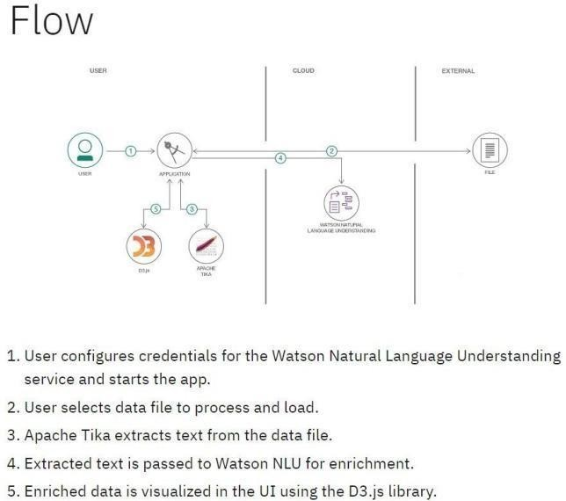

**User Stories**

Use the below template to list all the user stories for the product.

|  |  |  |  |  |  |  |
| --- | --- | --- | --- | --- | --- | --- |
| **User Type** | **Functional Requirement (Epic)** | **User Story Number** | **User Story / Task** | **Acceptance criteria** | **Priority** | **Release** |
| Customer (Mobile user) | Application | USN-1 | You can download the crude oil price by opening the Google Play Store app directly as a user. | I can access own decisions. | High | Sprint-1 |
|  | Available Products | USN-2 | Users of the application may instantly update the energy and oil prices while using it  because there are so many different products in the crude oil price app. | I can receive the data once click then confirm | High | Sprint-1 |
|  | Additional Features | USN-3 | Users can read the most recent news and see oil price charts.  Major Energy Quotes User View  The user may use many colour schemes. | I can view then read the price prediction. | High | Sprint-2 |
|  | [Expectations](https://developer.ibm.com/patterns/visualize-unstructured-text/) | [USN-4](https://developer.ibm.com/patterns/visualize-unstructured-text/) | User Can Convert Currency And Exchange Rates | I can expect | Medium | Sprint-1 |
|  | [Login](https://developer.ibm.com/patterns/visualize-unstructured-text/) | [USN-5](https://developer.ibm.com/patterns/visualize-unstructured-text/) | Log in as a user without using  your email address, username, or password. |  | High | Sprint-1 |
|  |  |  |  |  |  |  |
| [Customer (Web](https://developer.ibm.com/patterns/visualize-unstructured-text/) [user)](https://developer.ibm.com/patterns/visualize-unstructured-text/) |  |  | I can see the price of crude oil as a consumer. | I can view the price directly | High | Sprint-1 |
| [Customer Care](https://developer.ibm.com/patterns/visualize-unstructured-text/) [Executive](https://developer.ibm.com/patterns/visualize-unstructured-text/) |  |  | I am the user and I executive the pricing history. | I can accept the terms | medium | Sprint-1 |
| [Administrator](https://developer.ibm.com/patterns/visualize-unstructured-text/) |  |  | As a manager, it anticipates the results. | Show the result | High | Sprint-1 |
|  |  |  |  |  |  |  |
|  |  |  |  |  |  |  |
|  |  |  |  |  |  |  |